** NAME:Aryaman Mishra**

**REG. NUMBER: 19BCE1027**

**EXPERIMENT NO.6**

**DATE: 1-4-22**

**PSYCHOLOGY LAB RECORD BOOK FORMAT**

* **TITLE OF THE EXPERIMENT**

**STRESS MANAGEMENT**

* **AIM:**

To compute stress levels by filling in a question paper and discuss results on individual and group level.

* **MATERIALS REQUIRED:**

Question Pamphlet.Pen.

* **DESCRIPTION OF TEST:**

**Stress management** is a wide spectrum of techniques and [psychotherapies](https://en.wikipedia.org/wiki/Psychotherapy) aimed at controlling a person's level of [stress](https://en.wikipedia.org/wiki/Stress_(psychological)), especially [chronic stress](https://en.wikipedia.org/wiki/Chronic_stress), usually for the purpose of and for the motive of improving everyday functioning. Stress produces numerous physical and mental symptoms which vary according to each individual's situational factors. These can include a decline in physical health as well as [depression](https://en.wikipedia.org/wiki/Depression_(mood)). The process of stress management is named as one of the keys to a happy and successful life in modern society. Life often delivers numerous demands that can be difficult to handle, but stress management provides a number of ways to manage anxiety and maintain overall well-being.

Despite stress often being thought of as a subjective experience, levels of stress are readily measurable; using various physiological tests, similar to those used in [polygraphs](https://en.wikipedia.org/wiki/Polygraph).

There are several models of stress management, each with distinctive explanations of mechanisms for controlling stress. Much more research is necessary to provide a better understanding of which mechanisms actually operate and are effective in practice.

* **PROCEDURE**

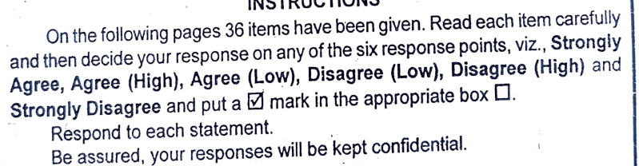

* **TABLE 1:**

**INDIVIDUAL DISCUSSION**

As we know that [stress has got a number of negative consequences for the individuals](https://www.mbaknol.com/management-articles/consequences-of-stress/), that is why every individual should take personal responsibility for reducing his or her stress level. There are a number of ways by which a person can either avoid stressful conditions, change them or learn to cope with them. Stress can be managed by an individual, which will enable him to regain control over his life.

Some of the stress reducing strategies from individual’s point of view are :

1. Knowledge About Stress. In the first stage, an individual should become knowledgeable about stress. He should know about the process and effects of stress. He must find out the major sources of his stress. He must anticipate stressful periods and plan accordingly in advance. He must be honest with himself and decide what he can cope with what he cannot.

2. Physiological Fitness. Exercise in any form can help people in coping with the stress. Non competitive physical exercise such as aerobics, walking, jogging, swimming, riding a bicycle, playing softball or tennis have been recommended by physicians as a way to deal with excessive stress levels. There is evidence to suggest that individuals who exercise are much less likely to suffer from certain types of stress related exercises. With proper exercise, diet control and non-smoking habits, blood pressure and cholesterol become controlled and the body becomes more resistant to pressures. People are more likely to get physically sick or emotionally depressed if they are over weight or poorly nourished.

3. Time Management. Most of the people are very poor in managing their time. They don’t know that what must be done and when it would be desirable to do so. The result of poor [time management](https://www.mbaknol.com/modern-management-concepts/time-management/) is feeling of work overload, skipped schedules and tension. A well organised person can often accomplish twice as much as the person who is poorly organised. Therefore, an individual must understand how to manage his time so that he can cope with tensions created by job demands. A few of the well known time management principles are :

* Preparing a daily list of activities to be attended to.
* Prioritizing activities by importance and urgency.
* Scheduling activities according to the priorities set.
* Knowing your daily schedule and handling the most demanding parts of a job when you are most alert and productive.

4. Assertiveness. An individual should become assertive. He should not say ‘Yes’ when he wants to say ‘No’. He should start saying No to people or managers who demand too much of his time. Being assertive is an important factor in reducing stress.

5. Social Support Network. Every person should have people to turn to, talk to and rely upon. Good friends become highly supportive during times of stress and crisis. Social net work includes friends, family or work colleagues. Expanding your social support system can be a means for tension reduction because friends are there when needed and provide support to get the person through stressful situations.

6. Readjust life Goals. Every individual must know what he really wants to do. This should relate to not only the major decisions of the life but to all activities in our life. He must know what is important for him. Because of the severe competition in life to go ahead, most individuals set very high standards and goals for themselves. These high expectations and limited resources to reach such expectations result in stress. Accordingly, every person must readjust his goals and make sure he has the ability and resources to reach such goals. Perhaps the goals should be established after the resources have been analysed.

7. Relaxation Techniques. Every individual must teach himself to reduce tension through relaxation techniques such as Yoga, mediation, hypnosis and biofeedback. 15-20 minutes a day of deep relaxation releases tension and provides a person with pronounced sense of peacefulness. Deep relaxation conditions will bring significant changes in heart rate, blood pressure and other physiological factors. Yoga is probably the most effective remedy for stress. Studies have revealed that Yoga has cured several stress related diseases.

8. Plan your life in Advance. So many times, people create situations which induce stress because they either did not plan or did a bad job of planning. The traditional Indian attitude of “whatever will be, will be” a way of accepting the unexpected difficulties in life. This attitude may be relevant in those situations over which we do not have any control like death in the family, but for other events in life, it is better to plan in advance, so that we can confront them with confidence when they occur.

Individuals may design their own strategies to reduce stress, but it is a must for the organisations to develop programmes that will help the employees in reducing their stress. This will lead to less employee turnover, absenteeism and as a result productivity will improve.

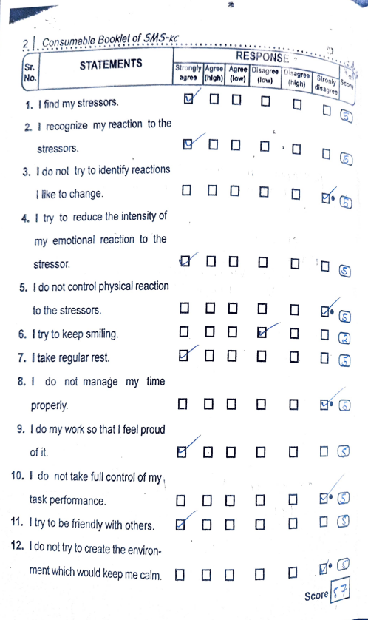

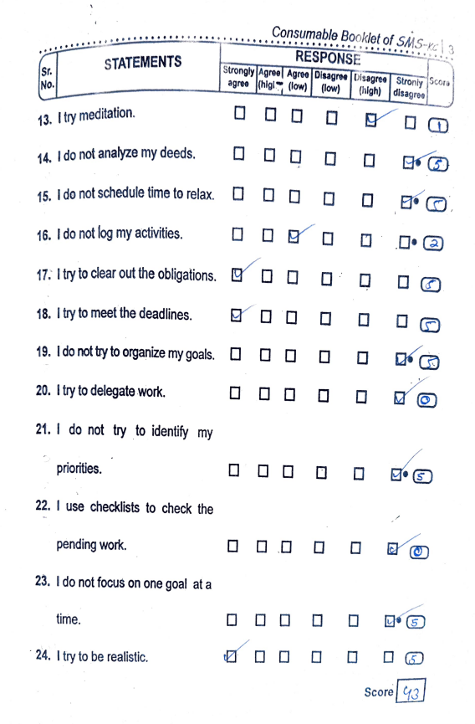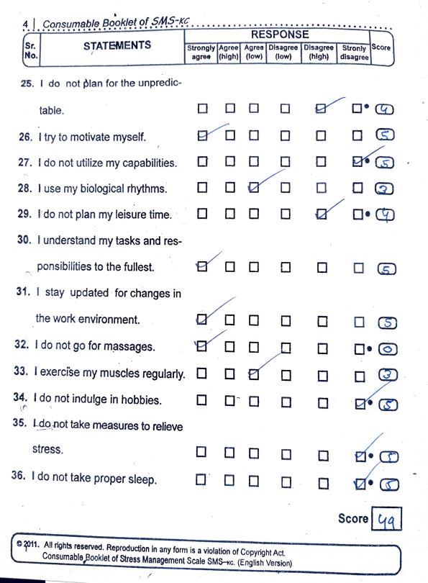

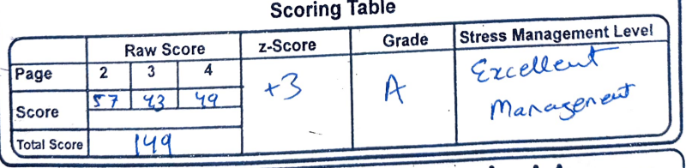

* **TABLE 2:**

**GROUP DISCUSSION**

It can be noted from the results that majority students don’t take care of their stress levels and that students with good management of stress tend to be more creative and have a big ego to themselves such that their personality overshadows any problems which are thrown at them.

Individuals may design their own strategies to reduce stress, but it is a must for the organisations to develop programmes that will help the employees in reducing their stress. This will lead to less employee turnover, absenteeism and as a result productivity will improve.

Some of the measures which organisations can take are;

1. Selection and Placement. Individuals differ in their response to stress situations. We know that ‘Type A’ individuals are more prone to stress. On the other hand, in the organisations there are certain jobs which are more stressful as compared to other jobs. While doing the selection and placement of the employees, these factors must be kept in mind. The individuals who are more prone to stress should not be put on jobs which are stressful. The individuals who are less prone to stress may adapt better to high stress jobs and perform those jobs more effectively.

2. Goal Setting. Based on extensive amount of research it has been concluded that individuals perform better when they have specific and challenging goals and they receive feedback on how well they are progressing towards those goals. Goal setting can reduce stress as well as provide [motivation](https://www.mbaknol.com/management-concepts/motivation/). It will result in less employee frustration, role ambiguity and stress.

3. Improved Communication. Sometimes due to lack of effective communication from the superiors, the employees do not know what they have to do and how they have to do it. This result in role ambiguity. Similarly, when two or more persons have contradicting role demands from an employee, it leads to role conflict if there is lack of proper communication. [Effective communication](https://www.mbaknol.com/business-communication/principles-of-effective-communication/) with employees reduces the uncertainty by lessening role ambiguity and role conflict.

4. Redesigning Jobs. Organisations should [redesign the jobs](https://www.mbaknol.com/human-resource-management/job-enrichment/) in such a way as to give employees more responsibility, more meaningful work, more autonomy and increased feed back. This will help reduce the stress caused by monotony, routine work, work overload or underload and role ambiguity. Job redesigning enhances motivation, reduces the stress among the employees and enhances “[Quality of work life](https://www.mbaknol.com/human-resource-management/quality-of-work-life-qwl/)“.

5. Participative Decision Making. If the [organisations give the employees participation in those decisions](https://www.mbaknol.com/human-resource-management/workers-participation-in-management/) that directly affect them and their [job performance](https://www.mbaknol.com/human-resource-management/appraising-employee-performance/), it can increase employee control and reduce the role stress. The main reason of role stress is that employees feel uncertain about their goals, expectations and how they will be evaluated. These uncertainties can be reduced by the management by giving the employees a right to participate in the decision making.

6. Building Teamwork. The management should try to create such work environment in which there is no provision for interpersonal conflict or inter group conflict. Such conflicts are the causes of stress, such should be prevented from building or eliminated if they develop. Accordingly such team work should be developed that groups and the members are mutually supportive and productive. Members of the group should consider themselves as members of the same family and seek social support from each other.

7. Personal Wellness Programmes. These personal wellness programmes focus on the employees total physical and mental condition. Organisations can provide facilities at their premises for physical fitness such as gyms, swimming pools, tennis courts etc. as well as psychological counselling. They should hold seminars or workshops to make the employees understand nature and sources of stress and the possible ways to reduce it. These workshops should help those individuals who are already under stress. Moreover, a supervisor can impact personal wellness of his subordinates through positive example, encouragement and by practising the [basic concepts and techniques of human resource management](https://www.mbaknol.com/human-resource-management/introduction-to-human-resource-management-hrm/).

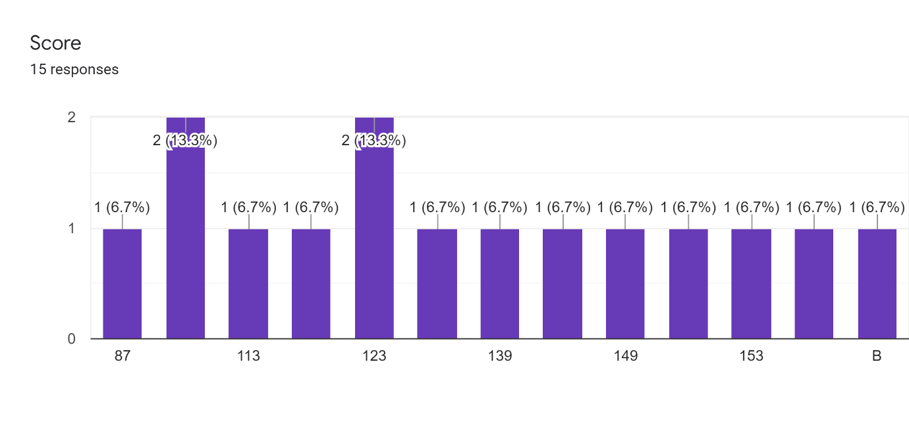

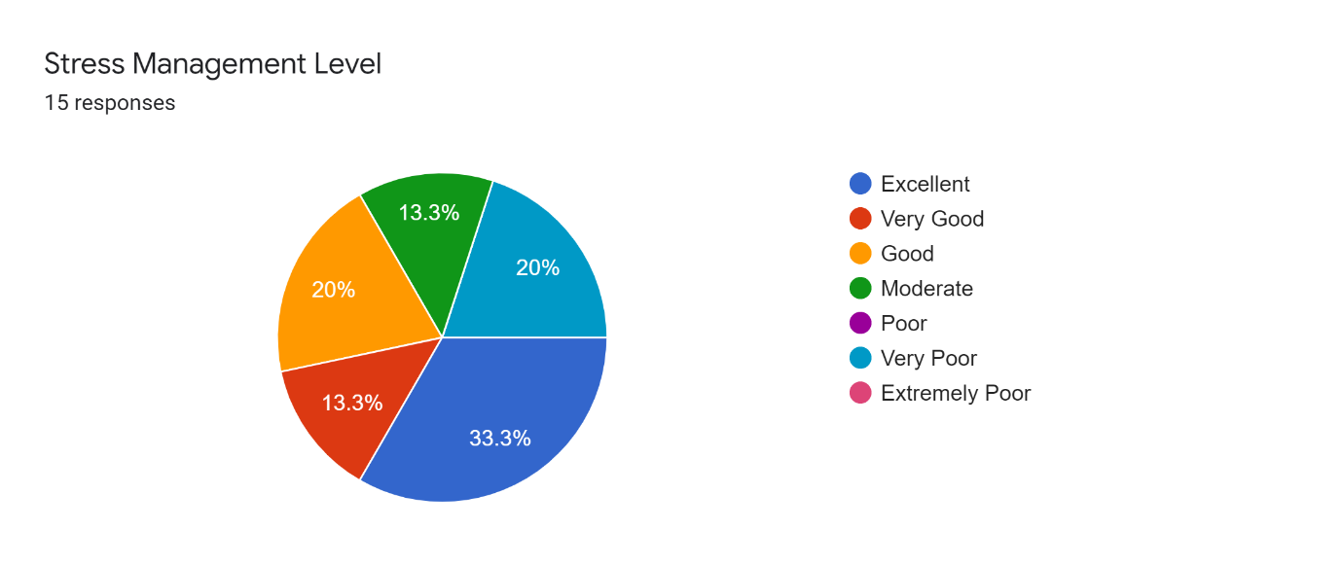

* **CONCLUSION**

Studies regarding Stress management at individual and group level has been succesfully studied,computed and recorded.

­­­­­­­­­­­­